Test Case: tc003_SPX_Dev5_Crear_Requisicion_Spot_Tipo_Cobro_CC_Urgent
Step 1 - Enter username and password and click to button Enter : Credentials Entered
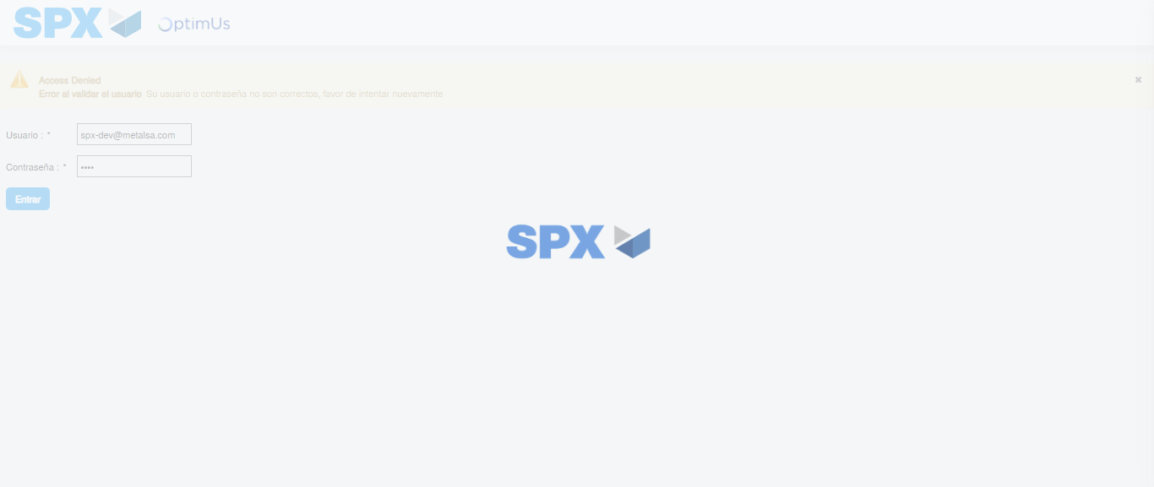Image file-name: QC_Testing-tc003_SPX_Dev5_Crear_Requisicion_Spot_Tipo_Cobro_CC_Urgent-1785959466723

Step 2 - Select to UEN and Access to Spot Buy Requisitions : UEN Correctly selected and Correct access
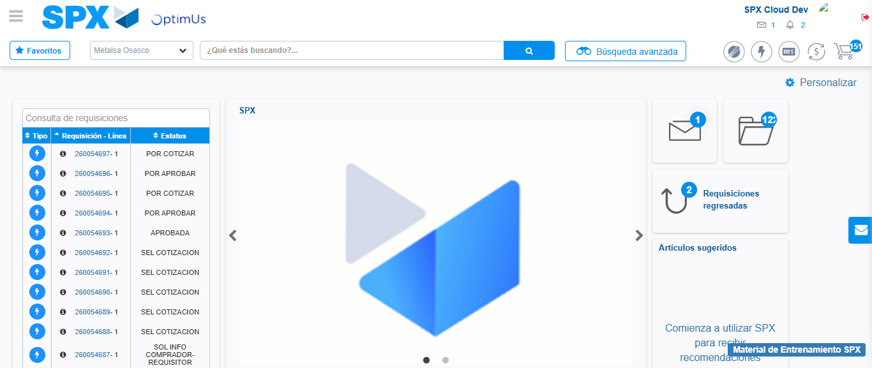Image file-name: QC_Testing-tc003_SPX_Dev5_Crear_Requisicion_Spot_Tipo_Cobro_CC_Urgent-1785959506936

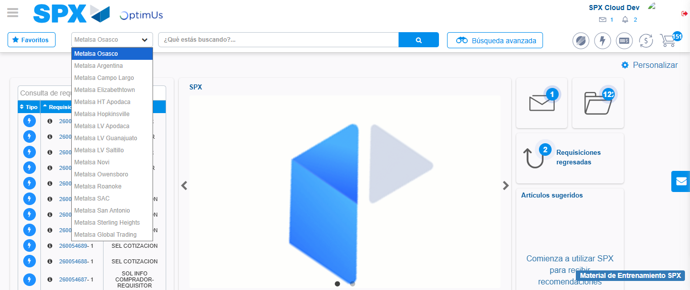Image file-name: QC_Testing-tc003_SPX_Dev5_Crear_Requisicion_Spot_Tipo_Cobro_CC_Urgent-1785959509628

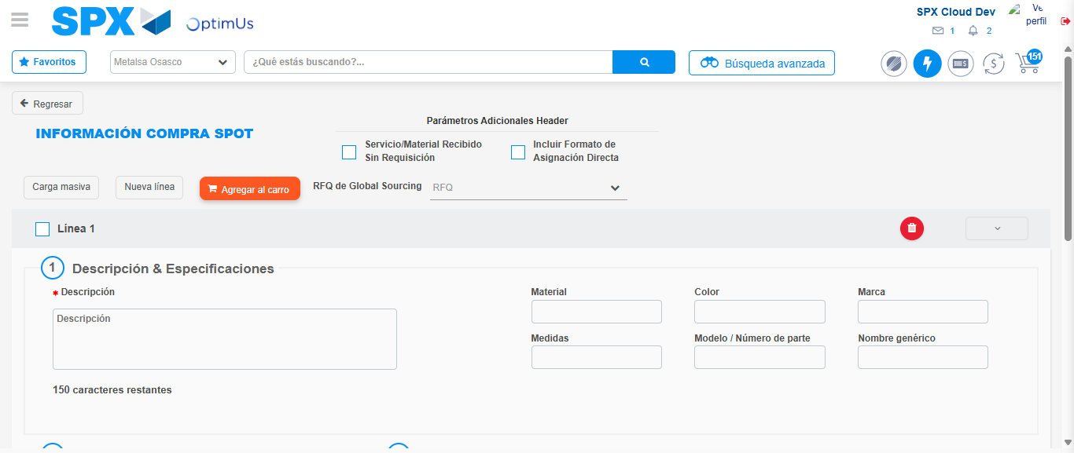Image file-name: QC_Testing-tc003_SPX_Dev5_Crear_Requisicion_Spot_Tipo_Cobro_CC_Urgent-1785959526566

Step 3 - Data Capture Spot Buy Requisition: Data captured correctly
Image file-name: QC_Testing-tc003_SPX_Dev5_Crear_Requisicion_Spot_Tipo_Cobro_CC_Urgent-1785959526820

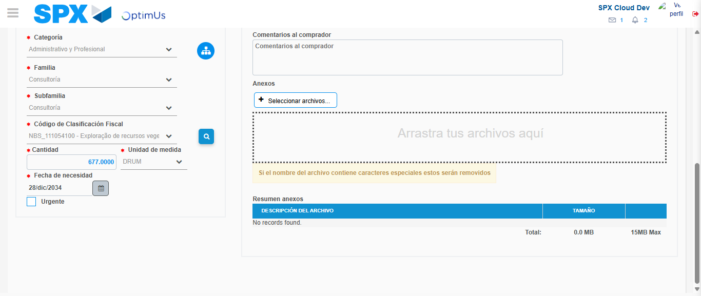Image file-name: QC_Testing-tc003_SPX_Dev5_Crear_Requisicion_Spot_Tipo_Cobro_CC_Urgent-1785959548822

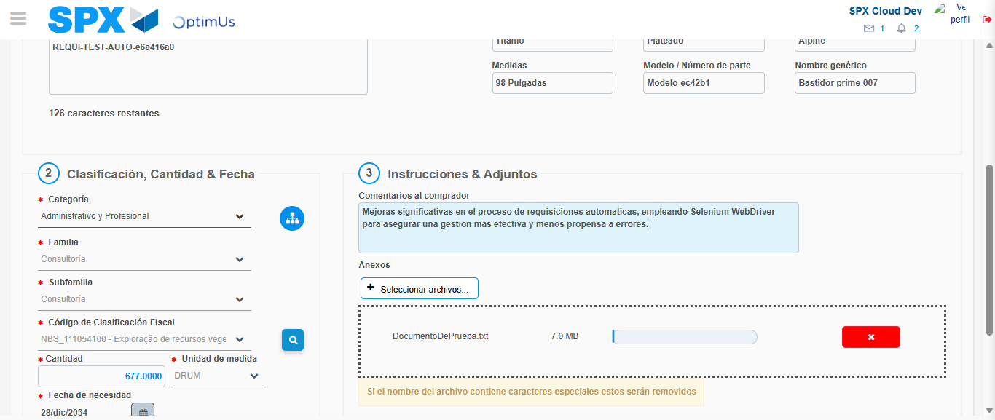Image file-name: QC_Testing-tc003_SPX_Dev5_Crear_Requisicion_Spot_Tipo_Cobro_CC_Urgent-1785959549619

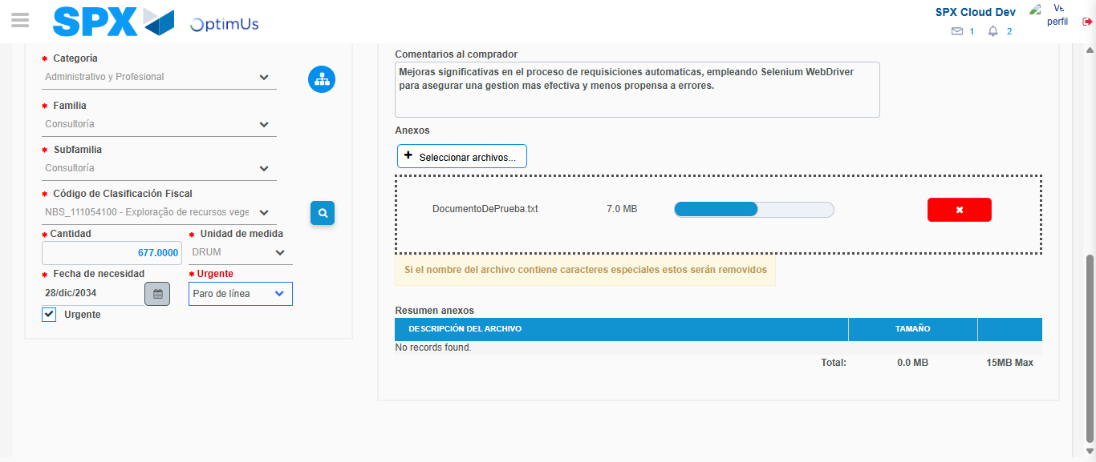Image file-name: QC_Testing-tc003_SPX_Dev5_Crear_Requisicion_Spot_Tipo_Cobro_CC_Urgent-1785959553301

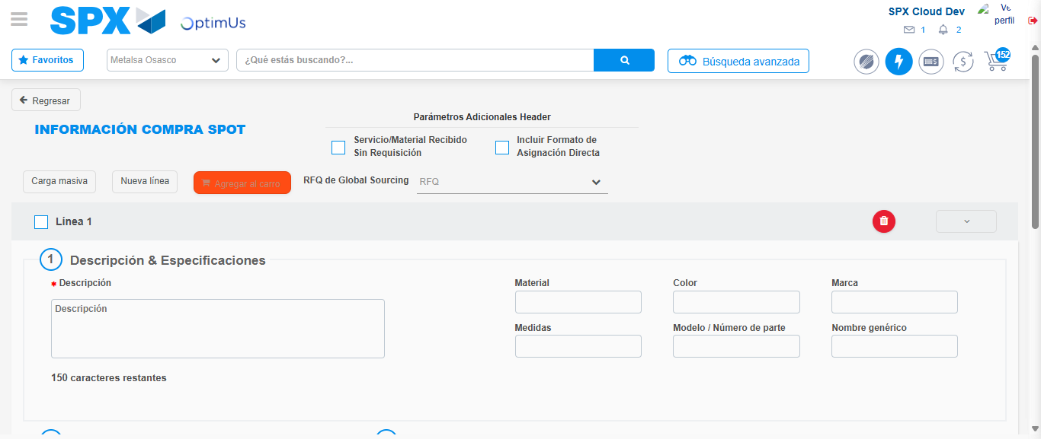Image file-name: QC_Testing-tc003_SPX_Dev5_Crear_Requisicion_Spot_Tipo_Cobro_CC_Urgent-1785959556959

Step 7 - Return to Main Page SPX : Return to Main Page SPX
Image file-name: QC_Testing-tc003_SPX_Dev5_Crear_Requisicion_Spot_Tipo_Cobro_CC_Urgent-1785959506936

Image file-name: QC_Testing-tc003_SPX_Dev5_Crear_Requisicion_Spot_Tipo_Cobro_CC_Urgent-1785959509628

Image file-name: QC_Testing-tc003_SPX_Dev5_Crear_Requisicion_Spot_Tipo_Cobro_CC_Urgent-1785959526566

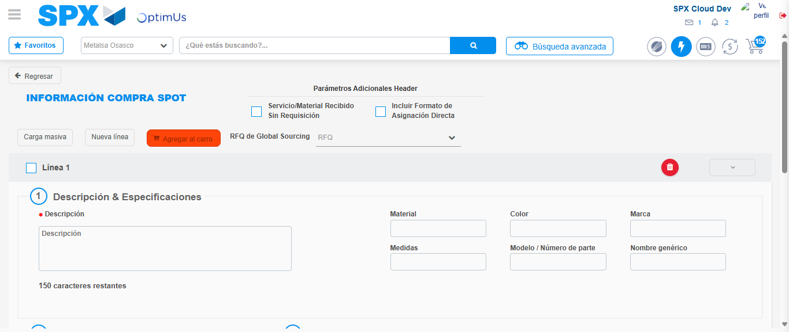Image file-name: QC_Testing-tc003_SPX_Dev5_Crear_Requisicion_Spot_Tipo_Cobro_CC_Urgent-1785959559172

Image file-name: QC_Testing-tc003_SPX_Dev5_Crear_Requisicion_Spot_Tipo_Cobro_CC_Urgent-1785959559351

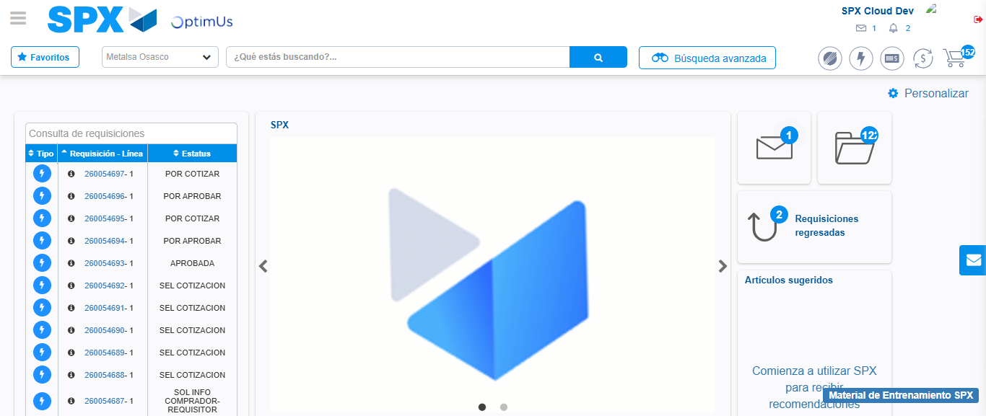Image file-name: QC_Testing-tc003_SPX_Dev5_Crear_Requisicion_Spot_Tipo_Cobro_CC_Urgent-1785959580365

Step 8 - Log Out : Log Out SPX
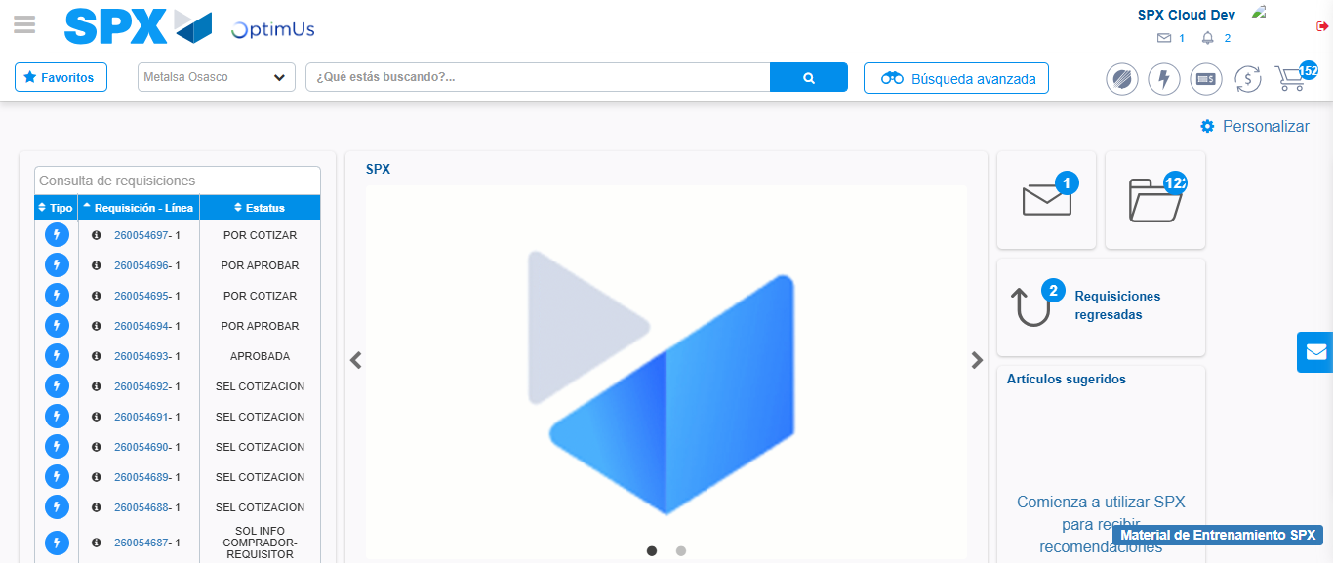Image file-name: QC_Testing-tc003_SPX_Dev5_Crear_Requisicion_Spot_Tipo_Cobro_CC_Urgent-1785959580688

